[Django Tutorial](https://docs.djangoproject.com/en/3.2/intro/tutorial01/)

**ORM Introduction**

[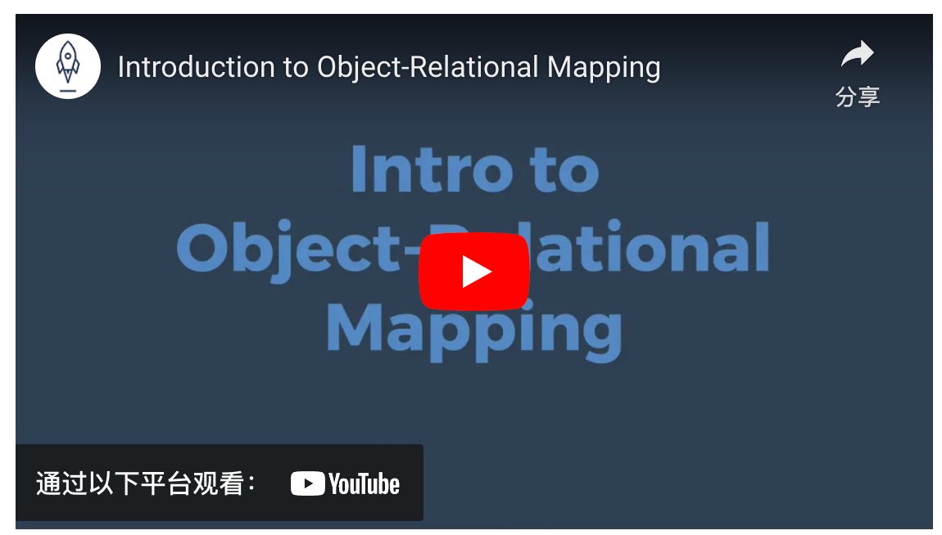](https://www.youtube.com/watch?v=dHQ-I7kr_SY)

[**Object relational mappers**](https://padlet.com/lsong4/2td48nxj10zh)

